Intermediate Level Report
DocuMind-AI

1. Introduction:
As part of the Intermediate Level AI Engineer internship task, I developed DocuMind-AI, a document-based question-answering application. The main idea was to build something that could understand information from an uploaded document and answer questions using that document as the primary source. The task required moving beyond a simple LLM API call. The application needed to include document upload, text extraction, chunking, embeddings, similarity-based retrieval, and grounded answer generation. DocuMind-AI was developed around this complete workflow.

2. Objective:
The main objective of DocuMind-AI is to make it easier for users to ask questions about a PDF or TXT document without manually searching the entire document. Instead of sending a question directly to an AI model, the application first searches the uploaded document for relevant sections. These sections are then provided to the AI model as context while generating the final answer. This approach helps keep the answer connected to the uploaded document instead of relying only on the model's general knowledge.

3. What I Built:
DocuMind-AI currently provides a simple interface where the user can:
- Upload a PDF or TXT document
- Extract text from the document
- Divide the extracted text into smaller chunks
- Generate embeddings for those chunks
- Search for relevant chunks based on a user's question
- Send the retrieved context to the Groq API
- Display the generated answer
- Display the retrieved document sections and their similarity scores
The internship requirements specifically call for these core components, including document extraction, chunking, embedding generation, vector/similarity retrieval, grounded answering, source-context display, and handling of invalid files or empty queries.
4. Technology Used:
The project was developed using:
- React + TypeScript – for the application interface and logic
- Vite – for development and production builds
- pdfjs-dist – for extracting text from PDF files
- @xenova/transformers – for generating text embeddings
- Xenova/all-MiniLM-L6-v2 – the embedding model used for document chunks
- Groq API – for generating the final answers
- CSS – for the application interface
- Git and GitHub – for version control and project submission

5. How the Application Works:
The application follows a simple RAG pipeline:
Upload → Extract → Chunk → Embed → Retrieve → Generate → Display

Step 1: Document Upload
- The user selects a PDF or TXT file through the upload interface. The application checks the file extension before processing it.
- For unsupported files, the application displays an error instead of trying to process them.
Step 2: Text Extraction
- For TXT files, the application reads the file directly.
- For PDF files, I used pdfjs-dist to read each page and extract the available text. The extracted page content is then combined into one text document.
Step 3: Chunking
- Large documents are divided into smaller sections before they are indexed.
- This is important because searching smaller pieces makes it possible to identify the parts of a document that are most relevant to a particular question.
- The internship task specifically expects long document content to be split into smaller sections before retrieval.
Step 4: Embedding Generation
- Each text chunk is converted into an embedding using the all-MiniLM-L6-v2 model.
- In simple terms, the embedding represents the meaning of the text numerically. The same process is later applied to the user's question so that the question and document chunks can be compared.
Step 5: Similarity Search
- When the user enters a question, the application creates an embedding for that question and compares it with the stored document embeddings.
- The most relevant chunks are selected and returned as the retrieved context.
- This is the retrieval part of the RAG workflow.
Step 6: Grounded Answer Generation
- The retrieved document sections and the user's question are then sent to the Groq API.
- The prompt instructs the model to answer using the retrieved document context. This means the model is not simply being asked the question by itself; it receives relevant information from the uploaded document first.
Step 7: Displaying the Result
- The final answer is displayed in the application.
- I also display the retrieved chunks below the answer, along with similarity scores. This makes it possible to see which parts of the document were used to support the answer.
- The internship requirements specifically encourage showing retrieved context so that the behaviour of the retrieval system is visible.

6. Testing:
I tested the application using the AI Engineer Internship Task List.pdf document.
The application successfully:
- Extracted 8,658 characters
- Created 11 document chunks
- Generated embeddings for the chunks
- Retrieved relevant sections for questions
- Generated answers using the retrieved context
I tested different types of questions to make sure the system was not simply returning generic responses.
- For example, when I asked about the Intermediate Level requirements, the application returned an answer describing document upload, text extraction, chunking, embeddings, similarity search, and grounded answer generation.
- I also tested a question whose answer was not available in the uploaded document. In that case, the application responded:
“I couldn't find this information in the uploaded document.”
This was an important test because the goal of the system is to reduce unsupported answers rather than make up information.

7. Error Handling and Validation
Basic validation was added to make the application easier to use. The application checks that:
- A document has been uploaded before asking a question
- The uploaded file is a PDF or TXT file
- The extracted document contains readable text
- Document chunks are successfully created
- A question has been entered before sending it to the AI
- API errors are displayed to the user
The internship task also specifically mentions basic handling for invalid files and empty queries.

8. Challenges Faced
One of the main challenges during development was getting PDF processing to work correctly in the browser.
- I initially faced an issue with the PDF.js worker configuration where the application displayed a “Setting up fake worker failed” error. I had to adjust the PDF worker configuration so that the worker file was correctly included in the Vite build.
- Another issue occurred with the Groq model configuration. Some model names that I initially tried were no longer available or were not accessible through the API. I checked the available models and updated the application accordingly.
- I also had to deal with TypeScript errors while configuring PDF.js. Resolving these issues helped me understand the difference between code that may work at runtime and code that also satisfies the TypeScript type definitions.

9. Project Architecture
The application was separated into different responsibilities instead of putting everything into one file. The main flow is:
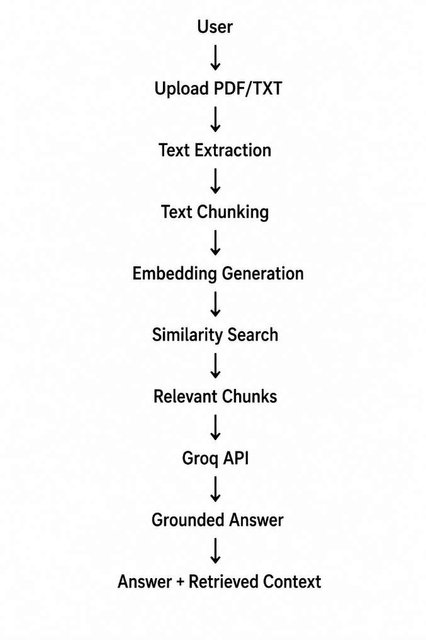
This separation makes the project easier to understand and maintain.

10. Result
The final application successfully demonstrates the main concepts expected from the Intermediate Level task. It is able to take a document, process its contents, create embeddings, retrieve relevant information, and use that information to generate an answer. The most useful part of the project for me was seeing the complete process working together. Before building this project, embeddings and retrieval were mostly concepts. During implementation, I was able to see how a document can be converted into searchable chunks and how those chunks can be used to improve the relevance of an AI-generated answer.

11. Conclusion:
DocuMind-AI helped me understand how a basic Retrieval-Augmented Generation system can be built from individual components. The project covers the main Intermediate Level requirements: document upload, text extraction, chunking, embedding generation, similarity-based retrieval, grounded answer generation, retrieved-context display, and basic validation. More importantly, the project gave me practical experience in connecting different parts of an AI workflow rather than treating the LLM as a standalone API. I completed the project with a working React/TypeScript application and pushed the source code and report to GitHub.

12. GitHub Repository:
- DocuMind-AI:
“https://github.com/hasini7-tatikonda/DocuMind-AI”

